ĐỀ THI GIỮA HỌC KÌ 2 – ĐỀ SỐ 1 MÔN: TIẾNG ANH 8 GLOBAL SUCCESS

LISTENING

Part 1. Listen then choose the right answers.
  - How will Mary travel to Scotland?

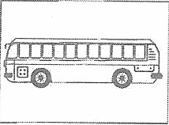 | 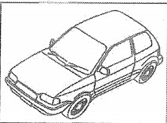 | 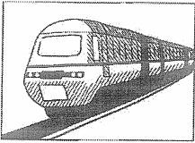
A | B | C
  - Where are the shoes?

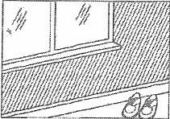 | 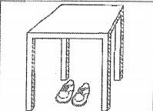 | 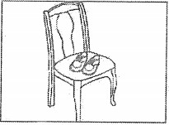
A | B | C
  - When will the football match next week?

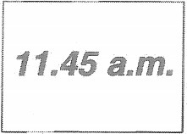 | 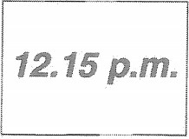 | 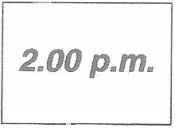
A | B | C
  - Which box of chocolates do they buy?

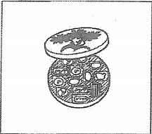 | 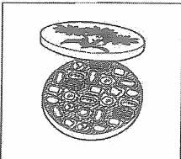 | 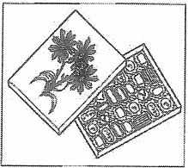
A | B | C
  - When is Wendy’s birthday?

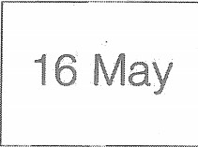 | 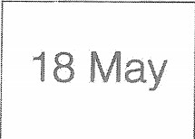 | 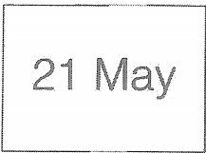
A | B | C

Part 2. You will hear a conversation about a flat for rent. Listen and complete questions 6-10. You will hear the conversation twice.
LONFLATS AGENCY
Flat for rent in: Putney
Number of bedrooms: (6)……………
Cost: (7) £ a month
Address: (8) 27… Street
When see flat: (9) Tuesday at ……………... Free from: (10)1st ………………………..

GRAMMAR-VOCABULARY- LANGUAGE FUNCTION

Part 1. Choose the word whose underlined part is pronounced differently from the others in each of the following questions.
11. A. honest | B. outstand | C. listen | D. student
12. A. raspberry | B. respect | C. spicy | D. especially
Part 2. Choose A, B, C or D for each gap in the following sentences.
- A: “Thank you very much for a lovely party.” – B: “ .”
  - You are very good B. Thanks
C. I'm glad you like the party D. I’d love to
- A: “Would you like something to eat?” B: – “ . I'm not hungry now.”
A. Yes, I would B. No, no problem C. No, thanks D. I’d love to
- Hai: "I’ve passed my driving test." - Huy: “ ”
  - Thanks a lot B. Do you like driving test?
C. Really! D. Congratulation!
- loss can be caused by noise pollution.
A. Sound B. Hearing C. Listening D. Hear
- Households pollute water sources by waste into ponds, lakes, and rivers.
A. damaging B. causing C. losing D. dumping
- A lot of fish has died recently because of the water in this lake.

A. contaminated B. contamination C. contaminate D. contaminating
- In this shop, there is a wide of decorative products that customers can buy before Christmas.
A. range B. sale C. convenience D. access
- If he trash around his garden, the garden would look very nice now.
A. will throw B. didn’t throw C. doesn’t throw D. don’t throw
- I find it hard to understand that foreigner because of his .
A. voice B. sound C. accent D. speech
- Singapore is an ideal destination for worldwide visitors because of its many .
A. tourist attractions B. attraction tours C. attractive tours D. attracted tours
- I Sydney Harbor twice, so this time I think I to a different place.
  - have visited - will go B. have visited - will be going
C. visited - will go D. visited - would go
- When she was playing on the beach, she saw the ocean drain away suddenly causing her to think of an imminent .
A. tornado B. tsunami C. earthquake D. volcanic eruption
- You shouldn’t bargain at the supermarket because every product has its fixed price its price tag.
A. in B.at C. on D. from

READING

Part 1. Read the passage. Circle the best answer A, B, C or D to fill in the blank.
(26) an earthquake happens, people can die from lack of food, water, and medical supplies. The amount of destruction (27) by an earthquake depends on where it happens, what time it happens, and how strong it is. It also depends on types of buildings, soil conditions and population. Of the 6,000 earthquakes in the world each year, only about 15 cause great damage and many deaths.
If seismologists could (28) earthquakes, we could save about 20,000 human lives each year. Man can control (29) things about nature, (30) we cannot control earthquakes.
26. A. After | B. Before | C. Until | D. During
27. A. was caused | B. is causing | C. is caused | D. caused
28. A. is predicted | B. predict | C. predicting | D. was predicted
29. A. less | B. more | C. much | D. many
30. A. so | B. but | C. and | D. too
Part 2. Read the following passage and mark the letter A, B, C, or D on your answer sheet to indicate the correct answer to each of the questions.
Ha Long Bay is a UNESCO World Heritage site in Quang Ninh province, in the northeast of Viet Nam. It has got over 1,600 islands and islets. Among the many ancient fishing villages in Ha Long Bay, only Cua Van floating village remains. All the houses and buildings in the village float on huge wooden rafts.
The villagers spend their days fishing and looking after the sea life. Then they sail to the mainland to trade

their fish for things like food, drinking water or clothes. Most children go to floating schools and then spend the rest of their time learning important skills like swimming and fishing. They also help out their parents as much as they can.
Their lifestyle may seem strange to many people, but it’s so wonderful to live among such natural beauty and know you are protecting it. The villagers are able to help preserve their beautiful bay because they live directly on the water.
- The word "they" in paragraph 2 refers to .
A. the houses B. the villagers C. the builders D. the schools
- According to the passage, the villagers’ lifestyle may seem to many people.
A. strange B. dangerous C. tiring D. boring
- The villagers not only fish but also the sea life.
A. damage B. take care of C. pollute D. look at
- What does “preserve” mean?
  - to keep up with somebody. B. to keep a particular quality.
C. not to save something. D. to make something worse
- The villagers are able to help preserve their beautiful bay because .
  - they live on the land B. they live far from the sea
C. they live directly on the water D. they don’t live directly on the water

WRITING

Part 1. Find out and circle the mistake in each sentence below.
- While she worked in the field, the tornado came. A B C D
- As soon as it rains, we go to club by bicycle. A B C D

Part 2. Write the sentences, using the words/phrases of words in brackets.
- My brother taught me how to use the computer. Then he bought one for me. (before)
→ ............................................................................................
- I am reading a book. My mother is cooking a meal. (while)
→ .. ………………………………………………………….
- Many Vietnamese students wear uniform. They go to school. (when)
→.............................................................................................
----------------------------THE END----------------------------

