
ĐỀ THI HỌC KÌ 1 – ĐỀ SỐ 5 MÔN: TIẾNG ANH 8 GLOBAL SUCCESS

Exercise 1. Listen to five short conversations and choose the correct answer.
- What did the doctor tell Richard to do?
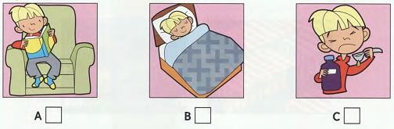
- What’s the matter with Richard now?
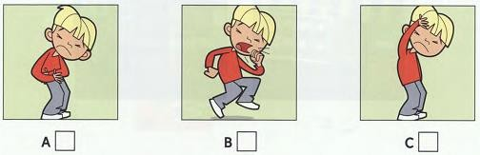
- What does Richard ask his mother for?
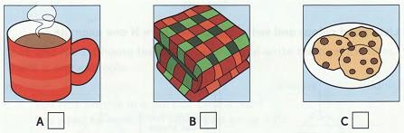
- What homework has Richard got to do?
A. History/ Maths B. Maths/ English C. English/ History
- When is Richard going to go back to school?
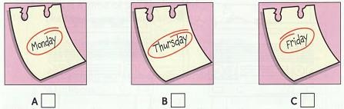

Exercise 2. Listen and complete the following questions.
 | GUITAR LESSONS
Name of music school: | The Stage Music School
Where: | (6) next to the
Address: | (7) London Street
Day of lesson: | (8)
Name of teacher: | (9) Mr.

Teacher’s telephone number: (10)
Exercise 3. Mark the letter A, B, C or D on your answer sheet to indicate the word whose underlined part differs from the other three in pronunciation in each of the following questions.
11. A. keep | B. know | C. kitchen | D. keen
12. A. return | B. future | C. picture | D. culture
Exercise 4. Choose the word which has a different stress pattern from the other
13. A. accept | B. costume | C. follow | D. mention
14. A. diversity | B. intelligent | C. generation | D. apparently

three in each question.

Exercise 5. Mark the letter A, B, C or D on your answer sheet to indicate the correct answer to each of the following questions.
- She worked hard, she passed the exam easily.
A. so B. because C. if D. although
- We often post many questions to discuss on a/an after school.
A. forum B. market C. club D. office
- If you the letter today, It'll arrive tomorrow.
A. send B. to send C. sending D. sends
- The xoe dance is a dance of the Thai in Viet Nam.
A. folk B. national C. special D. international
- Mr. Buong is old customer and honest man.
A. an – the B. the – an C. an – an D. the – the
- , we hold the winter festival on the 15 of December in lunar calendar.
A. Custom B. Traditionally C. In the past D. In the future
- “We‘re going on a trip to Ha Long Bay next week.” “ Really? !”
A. Good luck B. Have a nice time C. It’s your pleasure D. Take your time
- “How about fixing the dripping faucet.” - “ ”
A. We will. B. Good idea! C. Yes, please. D. I’m afraid not.

Exercise 6. Read the passage and mark A, B, C, or D indicate the correct word or phrasal that best fits blanks.
Each country has its own special traditions and customs just as individual have their own (23)
and daily routines. Many people find it difficult to get used to the customs of another country
(24) they go abroad. For example, in some Asian countries, people do not usually finish everything or their plates, because it is a (25) that they have not had enough to eat. Visitors from the West find it difficult to (26) used to this, because they usually eat everything up to show that they liked it. When an Asian host sees their (27) plates, he usually assumes that they want more.
- A. habits B. fashions C. styles D. practices

24. A. where | B. after | C. when | D. why
25. A. symbol | B. icon | C. warning | D. sign
26. A. make | B. get | C. maintain | D. look
27. A. clear | B. empty | C. vacant | D. blank

Exercise 7. Read the following passage and mark the letter A, B, C, or D to indicate the correct answer to each of the questions.
There is an ethnic group living in Ha Long Bay which is a UNESCO World Heritage site in Quang Ninh province, in the northeast of Viet Nam. It has got over 1,600 islands and islets. Among the many ancient fishing villages in Ha Long Bay, only Cua Van floating village remains. All the houses and buildings in the village float on huge wooden rafts.
The villagers spend their days fishing and looking after the sea life. Then they sail to the mainland to trade their fish for things like food, drinking water or clothes. Most children go to floating schools and then spend the rest of then time learning important skills like swimming and fishing. They also help out their parents as much as they can. Then lifestyle may seem strange to many people, but it’s so wonderful to live among such natural beauty and know you are protecting it. The villagers are able to help preserve their beautiful bay because they live directly on the water.
- The passage is mainly about
  - How Ha Long Bay became a UNESCO World Heritage.
  - The beauty of nature in Ha Long Bay.
  - The life of people in Cua Van ancient village.
  - The geographical features of Ha Long Bay.
- The word “they” in paragraph 2 is closest in meaning to .
A. the houses B. the villagers C. the builders D. the schools
- According to the passage, the villagers’ lifestyle may seem to many people.
A. strange B. dangerous C. tiring D. boring
- The villagers not only fish but also the sea life.
A. damage B. pollute C. look at D. look after
- According to the passage, which statements is NOT true?
  - Ha Long Bay has above 1,600 islands and islets.
  - Because of floating life, children in Cua Van floating village don’t go to school.
  - The children try to help their parents.
  - The villagers have preserved their beautiful bay.

Exercise 8. Find out the mistake in each following sentence.
- Lan often goes to school by bus, but today she goes on foot. A B C D
- His family was very poor, because he had to work for a company.

A B C D

Exercise 9. Rewrite the following sentences as directed (using the suggested words) so that the meanings stay the same.
- Jack has a new laptop; however, he never logs on his account on the Facebook. Although .
- The white car is cheaper than the black car
The black car is .
- Plant more trees and we will have fresh air.
If we .
- Mono is fond of admiring the flowers in my garden. Mono likes .
- They want to chase away bad luck and pray for a lucky new year. They enjoy .
- The Vietnamese decorate their houses with plants and trees. The Vietnamese use plants and .
----------------------THE END----------------------

