
ĐỀ THI HỌC KÌ 1 – ĐỀ SỐ 4 MÔN: TIẾNG ANH 8 GLOBAL SUCCESS
Exercise 1. Listen and choose the correct picture.
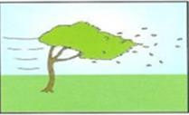

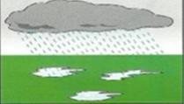
1. What’s the weather like this morning?
A B C
- Where are Nick’s shoes now?
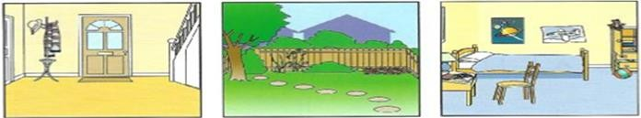
A B C
- Who’s going to the shops with Daisy?
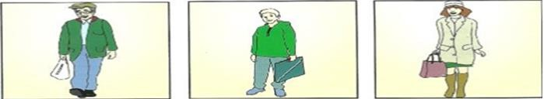
A B C
- What’s inside the cage?
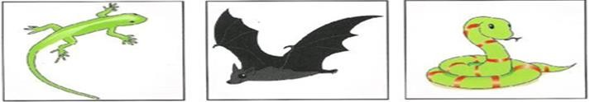
A B C
- How old is Sally’s grandmother?
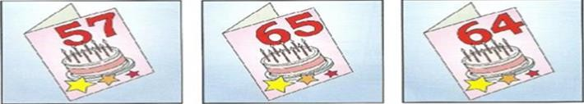
A B C
Exercise 2. Listen and write.

Please look for: sports bag  Name of child: Daisy (6) ………………………..…. Colour of bag: (7) ……………………………..…….  The bag was: next to (8) ……………………………  Inside the bag was: a (9) …………………………………..  Child’s address: (10) Top Street | 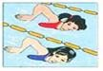
Exercise 3. Find the word which has a different sound in the part underlined.

11. A. wood | B. moon | C. cool | D. soon
12. A. girl | B. game | C. village | D. garden
Exercise 4. Mark the letter A, B, C or D that differs from the other three in the position of primary stress.
- A. understand B. experience C. interact D. afternoon
- A. staple B. impact C. revive D. tribal
Exercise 5. Choose the best answer to complete the sentences.
- In his free time, he is about messaging friends.
A. fond B. keen C. crazy D. interested
- It’s time, so the villagers are busy cutting and gathering their crops.
A. festival B. harvest C. growing D. planting
- Going out for breakfast has become a common in this city.
A. tradition B. lifestyle C. hobby D. practice
- clothes do minority people wear to Bac Ha Sunday Fair?
A. When B. What C. How D. Where
- It takes me more than hour to drive from my house to the city centre.
A. a B. an C. the D. x
- If we eat more vegetables and fruit every day, we healthy.
A. will be B. are C. be D. will
- Nhi: “What do you think about traditional games?” - Minh: “ ”
  - Yes, I don’t like it. B. I think I can.
C. I think it’s very interesting. D. I don’t think so.
- Lam: “Do you fancy going out for a drink?” - Phong: “ ”
  - I usually drink tea. B. Sure, thanks
C. Why are you asking? D. No, I prefer coffee.
- Unless you all of my questions, I can’t do anything to help you.
A. answered B. answer C. would answer D. are answering
- The tribal women know how to these threads into nice hats.
A. weave B. practice C. celebrate D. leisurely
- Mr Nam to the countryside next month.

A. go B. has gone C. went D. will go
Exercise 6. Choose the correct word for each of the gaps to complete the text.
Each country has its own special traditions and customs just as individuals have their own (26) and daily routines. Many people find it difficult to get used to the customs of another country (27) they go abroad. For example, in some Asian countries, people do not usually finish everything on their plates, because it is a (28) that they have not had enough to eat. Visitors from the West find it difficult to (29) used to this, because they usually eat everything up to show that they liked it. When an Asian host sees their
(30) plates, he usually assumes that they want more.
- A. habits B. fashions C. styles D. practices
- A. where B. after C. when D. why
- A. symbol B. icon C. warning D. sign
- A. make B. get C. maintain D. look
- A. clear B. empty C. vacant D. blank
Exercise 7. Read the text carefully and choose the best answer.
In Viet Nam, a market is a trading place, but many markets are not only about buying and selling things. They reflect the life of the community. A traditional market is a social gathering point for people of all ages and it is a new and exciting experience for children, a trading place for local craftsmen, and a chance for young people to meet. People go to the traditional market not only to buy and sell things but also to eat, drink, play games, and socialize. For example, if you go to Sa Pa Market, which is the highlands in the north of Viet Nam, you can see people wearing their nicest clothes and spending all day long at the market. They buy things, play the flute, dance, and sing. This is also a time to meet, make friends or look for lovers. That is why this kind of gathering is also called "Love Market”. Some other countryside markets in the Mekong Delta are held on boats. Most of the goods are sold at a floating market. The most exciting time is in the early morning when boats arrive loaded up with agricultural products.
- In Viet Nam, all markets are .
  - only trading places B. only about buying things
C. only about selling things D. not only about buying and selling things
- A traditional market is a social gathering point for .
  - young people B. people of all ages
C. local craftsmen D. children
- What can people do at the traditional market?
  - Sell and buy things only.
  - Buy and sell things, eat, drink and play games.
  - Buy things and eat.
  - Buy and sell things, eat, drink, play games and socialize.
- What do the ethnic people who go to Sa Pa Market do?

  - They wear their nicest clothes, buy things, play the flute, dance and sing.
  - They ride on a horse and sing.
  - They drink a lot of wine and dance.
  - They buy the nicest clothes at the market and look for lovers.
- Some of the markets in the Mekong Delta are held are called floating markets.
  - along the roads B. on the paddy fields
C. on boats D. in the morning
Exercise 8. Rewrite the following sentences without changing the meaning.
- My younger brother enjoys doing puzzles.
=> My younger brother is .
- Mr Smith is a more careful driver than his wife.
=> Mr Smith drives .
- Unless we leave now, we will miss the first bus.
=> If we don’t .
- He wanted to prepare for the exam. He turned off his mobile phone.
=> He wanted . (therefore)
- I like playing sports better than surfing the net.
=> I prefer .

--------------------THE END--------------------

