
ĐỀ THI HỌC KÌ 1 – ĐỀ SỐ 3 MÔN: TIẾNG ANH 8 GLOBAL SUCCESS

Exercise 1. Listen and choose the right picture.
- How does the man travel to Liverpool?
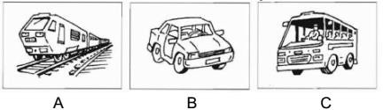
- Which bill has just arrived?
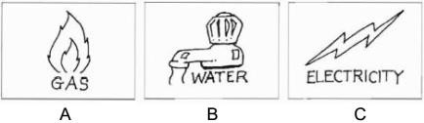
- What will they do tomorrow afternoon?
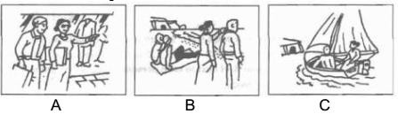
- How did the man hear about the fire?
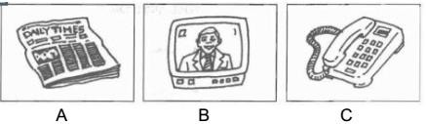
- What time did Mr. Thompson ring?
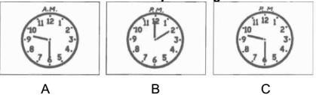

Exercise 2. Listen and complete the missing information.

PARK FARM
To see: Farm Animals
Food in: (6) Black Cat Tea | Opens at: (7)
Closes at: 5 p.m | Family ticket costs: (8) £
Don’t allow: (9) | Near: (10)

Exercise 3. Choose the best option to complete the sentences below.
11. Viet Nam is multicultural country with 54 ethnic groups.
A. a B. an C. the D. x
- I camping with my friends tomorrow if the weather fine.
A. am / will be B. went / was C. will go / is D. go / is
- does this laptop belong to? - It belongs to Jim.
A. Who B. Whose C. Which D. What
- The typical house type of the ethnic minority peoples is the .
A. stilt house B. igloo C. apartment D. lighthouse
- Jim doesn’t want to borrow money from anyone.
A. a B. an C. many D. much
- Do you think we a test tomorrow?
A. write B. wrote C. will write D. writes
- The Viet people have many traditional : weaving, carpentry, embroidery, ….. and their products are famous everywhere.
A. festivals B. crafts C. languages D. costumes
- Lan: Thanks to online learning, we could continue our studying during Covid-19 pandemic. - Mai:
.
A. Yes, I’d love to. B. Good idea!
C. Do you think so? D. Yes, certainly.
- Nam: Shall we visit a recycling factory in Ha Noi? - Ba: . A.Thanks for your idea. B. Right! What to say?
C. Great! When should we go? D. Don’t tell me about it.
20. Tet is an occasion for family in Viet Nam.
A. visiting B. meeting C. reunions
D. celebration

Exercise 4. Read and choose the best answer A, B, C or D for each blank.
The Bahnar, one of 53 ethnic (21) groups in Viet Nam, (22) primarily in Dak Lak and Kon Tum Provinces situated in the Central Highlands of Viet Nam, sharing borders with Cambodia and Laos.
In the centre of each Bahnar village, there is a grand (23) house called the Rong, which is also (24)
tallest building in the village, usually ranging from 15 to 20 metres. The Rong is the site of various events such as celebrations, religious ceremonies, and administrative meetings, and it serves as the main building of the village where visitors are welcomed. Men often (25) in the Rong in their leisure time, and bachelors and widowers use it as a temporary stay. Villagers also use the Rong for spiritual and religious rituals, and it houses ceremonial items such as rice wine and metal gongs.
21. A. popular | B. minority | C. majority | D. common
22. A. hold | B. stay | C. live | D. die

23. A. communal | B. private | C. brick | D. flat
24. A. a | B. an | C. x | D. the
25. A. take part | B. join | C. gather | D. do

Exercise 5. Read the text and choose the correct answer A, B, C or D to each question.
In southern Australia, there is a town where chimneys rise from the sand and there are big red signs warning people of “unmarked holes”. This town is Coober Pedy, often known as the “underground” town.
Coober Pedy is a small town over 1,000 miles from Canberra the country’s capital. Today it has about 1,800 residents. Originally, residents of Coober Pedy were opal miners, and even today it is still a mining town.
The Coober Pedy region is mostly a treeless desert. Very little plant life exists due to the region’s low rainfall and intense heat, so most of the residents live underground to escape the heat. They call their underground homes “dugouts”. These dugouts remain at a constant temperature, while surface buildings need air conditioning. The average maximum temperature is 30-32ºC, but it can get quite cool in the winter.
There are a number of underground hotels and tourist shops in the town. The town has become a popular stopover point and tourist destination.
- What is special about people in Coober Pedy?
  - They are coal miners. B. They live underground.
C. They need air conditioning. D. They receive many tourists.
- People in Coober Pedy live in “dugouts” because .
  - very little plant life exists B. they can do the mining there
C. it is much cooler there D. there are many hotels there
- The underlined word “it” in the passage refers to .
A. Canberra B. capital city C. opal D. Coober Pedy
- The underlined word “intense” in the passage probably means .
A. strong B. quiet C. weak D. interesting
- Which of the following is NOT true, according to the passage?
  - There are big red warning signs in Coober Pedy.
  - Houses underground in Coober Pedy are called “dugouts”.
  - The average temperature in Coober Pedy region is 30-32ºC.
  - There are a lot of tourist shops in the town.

Exercise 6. Find out the mistake in each following sentence.
- Much people in remote areas travel on foot.
A. Much
B. areas
C. travel
D. on
- Most families in the Viet Nam prepare offerings for the Kitchen Gods.
A. Most B. the C. prepare D. for
- Jane used to living with her grandparents when she was a child.
A. living B. with C. grandparents D. was

- You usually spend your free time to play games, don’t you?
A. usually B. your C. to play D. you
- If it will rain heavily tomorrow, we won’t go swimming.
A. will rain B. heavily C. won’t D. swimming

Exercise 7. Write meaningful sentences, using the words or phrases given. Change the word form or add some words if necessary.
- Many people/ be/ unemployed/ if/ robots/ popular/ future.
→
- They/ have/ graduation ceremony/ city hall/ this July.
→
- Why/ people/ the Central Highlands/ organise/ the Elephant Racing Festival?
→
- Nowadays/ teenagers/ rely/ technology/ than/ past.
→
- He/ adore/ play/ monopoly/ when/ he/ leisure time.
→
--------------------THE END--------------------

