
ĐỀ THI HỌC KÌ 1 – ĐỀ SỐ 1 MÔN: TIẾNG ANH 8 GLOBAL SUCCESS

Exercise 1. You will hear five short conversations. You will hear each conversation twice. There is one question for each conversation. For questions 1-5, choose the right answer.
- What time will the taxi arrive at the woman’s house?
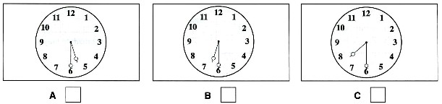
- What will they give George?
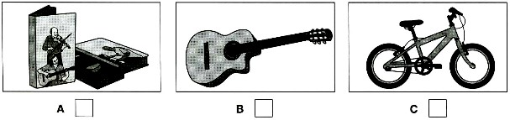
- Where will they sit?
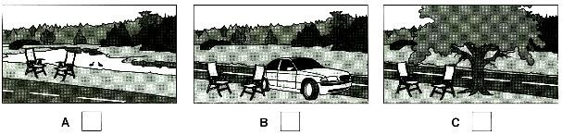
- What size does the woman buy?
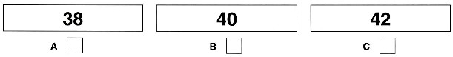
- Which ice cream will they have?
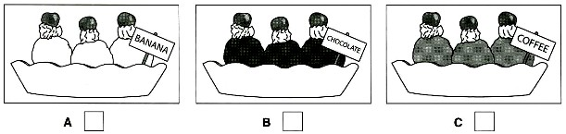

Exercise 2. Listen to a conversation and complete the table.

 | Radio 33 Competition
 | For students younger than: | 16
 | Date of competition: | (6)… December
 | Place: | (7) Town ………………………
 | Starts at: | (8)… pm
 | First prize: | (9)… ride
 | For information phone: | (10) Maggie……………………

- A. pet B. letter C. let D. set
Exercise 3. Find the word which has a different sound in the underlined part.
- A. food B. tooth C. good D. smooth

Exercise 4. Circle A, B, C or D for each gap in the following sentences.
- I always enjoy to my grandfather. He always tells me great stories.
A. to talk B. to talking C. talking D. talk
- The Internet allows us to communicate friends from different parts of the world.
A. to B. with C. for D. of
15 ‘I was wondering if you’d like to go to Da Lat Flower Festival’ ‘- When does it take place?’
A. Not bad! B. Are you sure? C. For what? D. Sure, I’d love to!
- Red envelopes are believed to bring good on Tet holiday.
A. luck B. love C. wish D. hope
- Linh wanted to make some pies but didn’t have apples; , she decided to bake a cake.
A. therefore
B. in contrast
C. namely
D. so
- There’s a of having parties at Christmas.
A. habit B. rule C. tradition D. practice
- Mr. Ba: “Children in my village often fly their kites in dry rice fields.”
Mrs. Black: “ ”
A. It’s right up my street! B. That’s awesome.
C. Exactly what I want. D. How interesting!
20. ethnic Khmer live in Mekong Delta of Vietnam.
A. The / - B. The / a C. A / the D. The / the

Exercise 5. Read the passage. Circle the best answer A, B or C to fill in the blank.
The country is more beautiful than a town and (21) to live in. Many people think so and go to the country for the summer holidays though they cannot live there all the year round. Some have a cottage (22)
in a village so that they can go there whenever they have time.
English villages are not all alike, but in some ways they are not different (23) one another. Almost every village has a church, the round or square tower of which can be seen for many miles around. Surrounding the church is the churchyard, where people are buried.

The village green is a wide stretch of grass, and houses or cottages are built round it. Country life is now fairly
- and many villages have water brought through pipes into each house. Most villages are so
- some small towns that people can go there to buy what they can’t find in the village shop.

21. A. please | B. pleased | C. pleasure | D. pleasant
22. A. build | B. building | C. built | D. is built
23. A. from | B. with | C. on | D. for
24. A. difficult | B. comfortable | C. enjoyable | D. improved
25. A. far away | B. out of | C. beyond | D. close to
Exercise 6. Read the passage. Circle the best answer A, B, C or D to each of the questions.
The Tay live mainly in the Northeastern part of Viet Nam. They live in large and crowded villages with hundreds of houses. They live in houses built on stilts. They are mainly farmers, and they grow rice on terraced fields. They also raise cattles and poultry. Tay traditional dress is made from homegrown cotton. There is usually not much embroidery or other decorations. Women wear skirts or trousers, with short shirts inside and long one on the outside.
They have many festivals and holidays in a year. The Lunar New Year and the mid-July festivals are the most lavishly organized. During festivals, people in many places play con throwing, badminton, tug-of-war, dragon dancing, or chess.
The Tay eat mainly sticky rice. On festival occasions, they make many kinds of cakes, such as banh chung
(sticky rice square cakes), banh day (sticky rice round cakes) or banh khao (cakes made of white rice flour).
- Which of the following best describes the main idea of the passage?
- The Tay live in the Northeastern part of Viet Nam.
- The life of the Tay in Viet Nam.
- The Tay have many festivals and holidays in a year.
- How the Tay earn their living.
- What do the Tay mainly eat?
  - sticky rice B. sticky rice and round cakes
C. sticky rice and square cakes D. square cakes
- Which is NOT true of the Tay?
  - They live in stilt houses. B. They grow rice on terraced fields.
C. They wear clothes with much embroidery. D. They raise cattles and poultry.
- Which is TRUE of the Tay’s life?
  - They mainly work in agriculture. B. They work in industry.
C. They have one very important festival a year. D. They don’t eat sticky rice.
- The word "lavishly" is closest in meaning to .
  - seriously B. carefully C. luxuriously
D. happily

Exercise 7. Rewrite second sentences with the same meaning.

- Study hard and you will pass your exam.
→ If …………………………………………………………
- Duong is fond of travelling and has been everywhere.
→ Duong is keen ……………………………………………
- My mother cannot cook as well as me.
→ I can.....................................................................................
- Despite being tired, he did the test very well.
→ Although .............................................................................
- A sports car goes faster than an ordinary one.
→ An ordinary car goes ............................................................

Exercise 8. Give the correct form of the word in the rackets in the following questions.
- Nga eats more than Tung does because she likes fast food. (HEALTHY)
- The houses of many ethnic groups are used to worship the ancestors. (COMMUNE)
- Most of the Central Highlands is . (MOUNTAIN)
- Do villagers today dress as in the past? (TRADITION)
- I am in her hometown with a lot of paddy fields. (INTEREST)
------------------THE END------------------

